Unit Terms and Objectives
Discovering Sociology – Chapter 1 The Sociological Perspective - Chapter 16 Marriage and Family
Terms & Concepts (Understand each of the following means and how it applies to the study of Sociology
Sociological Perspective Marriage and Family

Sociological Perspective
Society
Social Location
C. Wright Mills
History & Biography
Social Sciences
Generalizations
Origins of Sociology
Comte & Positivism
Spencer & Social Darwinism
Marx & Class Conflict
Durkheim and Social Integration
Weber and Protestant Ethic
Values in Research
Verstehen and Social facts
Sociology in North America
Harriet Martineau
Figure 1.3
W.E.B. Du Bois
Jane Adams
Basic (Pure) and Applied
Theoretical Perspectives
Symbolic Interactionism
Functional Analysis
Conflict Theory
Levels of Analysis

Family
Polygyny
Polyandry
Household
Nuclear/Extended Family
Orientation/Procreation
Defining Marriage??
Endogamy
Exogamy
Decent
Marriage in the Theoretical Perspectives
Functionalist – a family’s basic functions (6)
Conflict Perspective – Role of power and control
Symbolic Interactionism – the symbols of marriage
Romantic Love
Social Channels of Love and Marriage – India?
Propinquity
Homogamy
Marital Satisfaction
Child Rearing
Melvin Kohn
Empty Nest
Diverse Family’s
African American
Latino
Asian
Native American
One Parent
DINKS
Blended Families
Gay and Lesbian
Trends in US Families
Cohabitation
Sandwich Generation
Divorce
The Dark and Bright Side of Marriage

Objectives/Unit Targets For Sociological Perspective
You will be expected to…
- Explain why both history and biography are essential for the sociological perspective.
- Know the focus of each social science.
- Trace the origins of sociology, from tradition to Max Weber.
- Summarize the opposing arguments in the debate about values in sociological research.
- State what Verstehen is and why it is valuable.
- Trace the development of sociology in North America and explain the tension between objective analysis and social reform.
- Explain the basic ideas of symbolic interactionism, functional analysis, and conflict theory.
- Explain how research versus reform and globalization are likely to influence sociology.

Objectives/Unit Targets For Family and Marriage
You will be expected to…
- Define marriage and family and summarize their common cultural themes.
- Contrast the functionalist, conflict, and symbolic interactionist perspectives on marriage and family.
- Summarize research on love and courtship, marriage, childbirth, child rearing, and family transitions.
- Summarize research on families: African American, Latino, Asian American, Native American, one-parent, couples without children, blended, and gay and lesbian.
- Discuss changes in the timetable of family life, cohabitation, and elder care.
- Summarize problems in measuring divorce, research findings on children and grandchildren of divorce, fathers’ contact after divorce, ex-spouses, and remarriage.
- Summarize the dark and bright sides of family life.
- Explain the likely future of marriage and family.


What are your personal experiences? These should drive the kinds of knowledge that a sociologist finds interesting.

Sociology research questions – What might we want to ask to find something out?
- What meanings do we assign to behaviors and objects?
- What are the intended and unintended consequences of our actions and behaviors?
- Who benefits and who loses from the way things are done?

Things are not always what they seem?
- This motto pushes sociologist to really get to know the people we study.
- Look around with your eyes open
The compelling issues of the day shape the kind of knowledge that sociology creates

- Drug use in Waukesha County
- Health Care
News Story# 1
http://www.washingtonpost.com/blogs/wonkblog/wp/2014/08/25/three-quarters-of-whites-dont-have-any-non-white-friends/

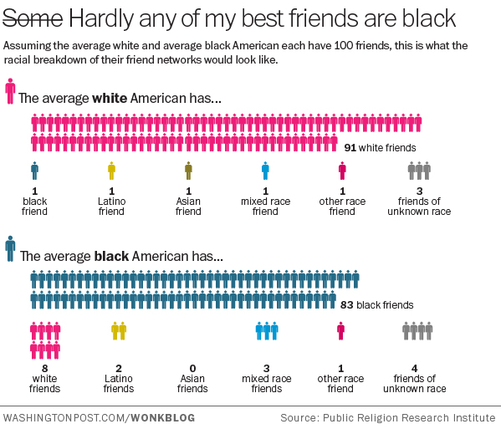
Follow the link and use this Washington Post Article as your first News Story of the semester. On the following page you will see the format for carrying out each News Story.

What are Sociology News Stories?
News Stories are a way for you to get interested in the related to Sociology. Take 15 minutes to find and read an article related to Sociology. This will become much easier once we get our feet a little more wet in the semester. You should look for articles that are related to your interest. IE the environment, Health and Wellness, Sports, etc.
Resources:
- http://topics.nytimes.com/top/news/science/topics/sociology/index.html
- http://sociology.alltop.com/
- http://www.world-newspapers.com/sociology.html
News Story:
- Read a Sociology article either online, (cnn.com, jsonline.com etc.) or in an actual newspaper. Do not cut articles out of Library News Papers. Make a copy of the article or buy your own.
- Be sure to search for an article that you are interested in and it has a length that is suitable for this assignment. This meaning don’t read an article three sentences long or 25 pages long.
- Either print out the article or cut the article out of the newspaper. This should be stapled to your loose-leaf sheet when you hand it in.
- Gather some sort of opinion and understand the basics of your article.

FACT
- Write a ½ page summary of this article. You can either type this or write it out by hand. Most students’ hand writes this assignment because it should only take about a ½ an hour to complete at the most.

OPINION
- Write a ½ page on how you feel about this topic. If it is a story about a murder, then write how angered you are and how you feel our society is going to the dogs. This is for me to read only, so emotion is something you should have when writing this portion of the assignment.

- This can be handed in any day of the week. I will take them out of the basket on Wednesday.

**** I will also be giving slight extra credit for those who include a unique Sociological Study on their Test’s throughout the semester. There will be a blank on the test that you may choose to fill with information and your perspective on a recent Sociological Study.

The Urinal Game Name________________________ Period_________________
Scenario #1 Students are to assume a cultural transmission of etiquette based on the norms of interaction for heterosexual American males in public restrooms. In the end I state, “You will be presented several scenarios from which you must select the proper urinal to use.”
Place an X over the uninal you think is most likely to be used
[] 0 0 0
Now briefly list why you would choose this urinal?
_______________________________________________________________________________________________________________________________________________________________________________________________________________________________________________________________
Notes on possible outcomes:
_______________________________________________________________________________________________________________________________________________________________________________________________________________________________________________________________
Scenario #2 In this scenario a man enters a restroom but finds it occupied with an individual at the far left urinal. Which of the following urinals does the man use now?
Place an X over the urinal you think is most likely to be used
[] 0 0 (I)
Now briefly list why you would choose this urinal?
_______________________________________________________________________________________________________________________________________________________________________________________________________________________________________________________________

Notes on possible outcomes:
_______________________________________________________________________________________________________________________________________________________________________________________________________________________________________________________________
Scenario #3 In our final scenario, a man enters a restroom occupied by an individual at the far left and far right urinal. What does the man do now?
[] (I) 0 (I)
Now briefly list why you would choose this urinal?
_______________________________________________________________________________________________________________________________________________________________________________________________________________________________________________________________
Notes on possible outcomes:
_______________________________________________________________________________________________________________________________________________________________________________________________________________________________________________________________
Discussion Questions
- What do these social encounters tell us about ourselves and our society?
- What are the expectations of behavior in a men’s public restroom?
- What are the expectations of behavior in a college classroom… in a football game, on a sidewalk?
- Why have norms?
- “I don’t think guy’s actions outside the bathroom are all that different than inside the bathroom,” once stated a female student. “They try to act all tough and independent outside the bathroom too.” Why do men act this way?
- Reflect on the ways by which we construct meaning and derive understanding. Like all actions, the “things we do in the bathroom” are understood only in a social environment. Stated in another manner, any given action must be interpreted within its particular cultural, historical, and situational backdrop. To bring this point home, I identify the fluid nature of other “bathroom-like” customs. For instance, I tell students that urinating at a urinal will not get one arrested, but doing so in a public alley might. Using another illustration, the unzipping of one’s pants in a public restroom is a general norm. But vary the social context and one varies also the meaning and symbolic understanding of unzipping one’s pants.
http://www.nola.com/katrina/index.ssf/2014/08/hurricane_katrina_then_and_now.html#incart_big-photo

